London Borough of Hounslow Memorial Donation Request Application Form
A memorial bench or tree donation is a thoughtful way to create a place for family and friends to reflect on memories and shared moments.
Lampton Services Greenspace offer a donation service within Hounslow’s parks, open spaces, and cemeteries
For any requests that are not within the Parks service, Lampton Services Greenspace will do their best to advise on which team to contact.
Items Available
- Blackburn Metal Bench – with brass plaque on a new concrete pad: £1,778.64
We also offer memorial benches at a reduced rate at locations where an existing bench is broken and not repairable as there is already a concrete pad in place.
- Blackburn Metal Bench – with brass plaque on existing concrete pad: £1,387.08
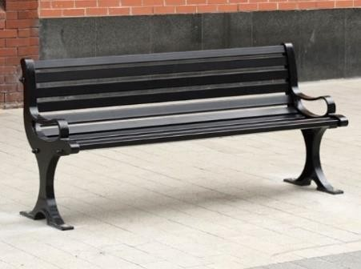
- Standard Tree – watering for the first 2 years included: £690
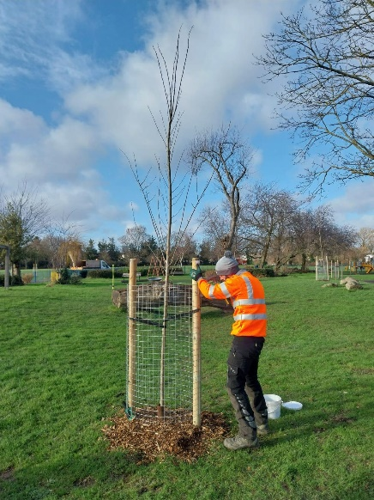
Each memorial tree request will be managed by the Lampton Services Greenspace Tree Manager who will determine what tree species are suitable for the location that you have requested and will only be planted during the winter season.

Terms and Conditions Lampton Services Greenspace will not be involved or able to influence the decision-making process on any requests outside an area/park we manage.
- Plaques will only be fitted to new Blackburn 'Anti-Vandal' Seat benches.
- All benches will be bolted to a new concrete pad or on to an existing concrete pad for longevity and security.
- If your request requires a new bench pad, then a site visit will be arranged with you and the site manager to determine a suitable location.
- If it is not viable to install a new bench pad in a new location, we may offer a reduced rate by using an existing pad if a bench needs replacing.
- Each memorial tree request will be managed by the Lampton Services Greenspace Tree Manager who will determine what tree species are suitable for the location that you have requested.
- Trees will only be planted during the winter season; this helps optimise their growth and gives the trees the best chance to establish themselves. Any requests made earlier in the year will be paused until planting season.
- There may not be capacity to plant new trees on certain sites, this will be shared with you during initial discussions.
- While we do our best to maintain all the new trees we plant, 5-10% of new trees fail to establish within the first 2 years. In these cases we will replace the tree where required.
- You will be notified on completion of the bench being installed or the tree being planted.
- We are unable to provide an unveiling event, but you can hold a small family gathering if you wish.
- Any large events which are advertised or could attract a large number of people would need to be approved by the LBH Events team.
- Each item that is donated will be managed as Council property and we reserve the right to remove or relocate any donated items if deemed a hazard to the public

Please confirm you understand the costs of the items and terms and conditions available and are happy to continue the application. ☐

Application Form

To request a memorial bench or tree, please email this form back to parks@hounslow.gov.uk with subject line "memorial donation" and your “surname.”
Please select the item that you would like to request:
Choose an item.
Customer Contact Information
Customer Name:
Email:
Phone Number:

Bench or tree location
Site Name:
What3Words of bench or tree:

Memorial Plaque Wording (total of five lines and a total of 50 characters including spaces per line).
Line 1: | Click or tap here to enter text.
Line 2:
Line 3:
Line 4:
Line 5:

Once Lampton Services Greenspace has approved your application form, a formal quote with bank payment details will be sent to the email address you have provided for you to make a direct bank transfer. Please note we do not accept any other forms of payment currently.
We would look to acknowledge receipt of your request within 14 working days and contact you to discuss your request further within 30 working days. Given that each request needs to be individually reviewed and site visits carried out, we cannot provide a guaranteed time for a decision however we will do our best to confirm an outcome as fast as possible once we have the information required.
Disclaimer:
I confirm that I have read all the above information and checked my answers in the application form. I understand that any mistakes will cause delays or termination of my application. I also consent to Lampton Services Greenspace to contact me via the information I have provided.
Ticking this box constitutes as a signature ☐
Date: Click or tap to enter a date.

