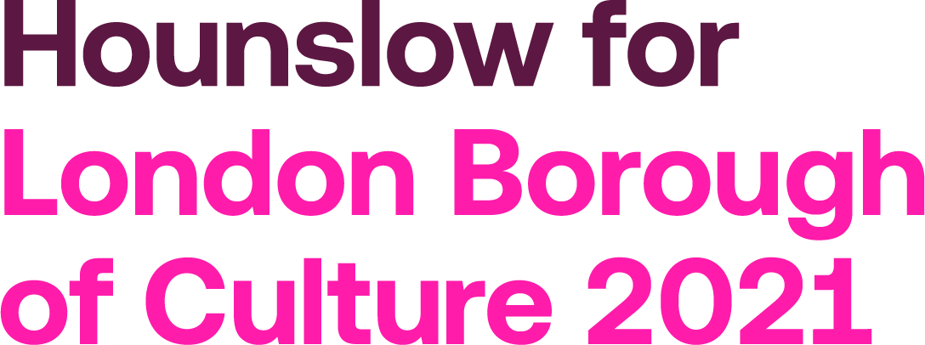

xx October 2019

Dear Mayor of London,
I am writing on behalf of (please insert company name) to give our full support to Hounslow’s bid to be London Borough of Culture 2021.
We are Hounslow. We’re a long, thin borough stretching all the way from the centre of town to the home counties. A borough of roads, railways, rivers and canals with lots of leavings and landings.

It’s made us into a bustling, busy place. Full of hard workers and self-starters. Always on the move, always changing.

It turns out, Hounslow is one of the most connected places in the world, but we’re not yet as connected to each other as we should be.

We know there’s so much more we can achieve in our strip of London, from
Chiswick to Feltham, if we can find a way to bring our very different communities
closer together. It takes more than roads to connect people, it takes culture.

In fact, we want to create an unstoppable movement of people, ideas and opportunities because we believe culture sets us free.

We can show you how we have engaged to create a culture superhighway of events, initiatives and projects that can bring our different parts together, spark ideas and unlock opportunity. We can also prove that if Hounslow secures the £1.35m, we will collectively multiply its value and leave a lasting legacy for our communities.

We back the bid. We want you, the Mayor of London, to back Hounslow.
GoHounslow!

____________________
(Name)
(Position)

